Lab 11
1 Generative AI (GenAI)
- Description: A broad category of artificial intelligence models designed to generate new content, such as text, images, code, or music, that is original but realistic. It learns patterns and structures from existing data to create novel outputs.

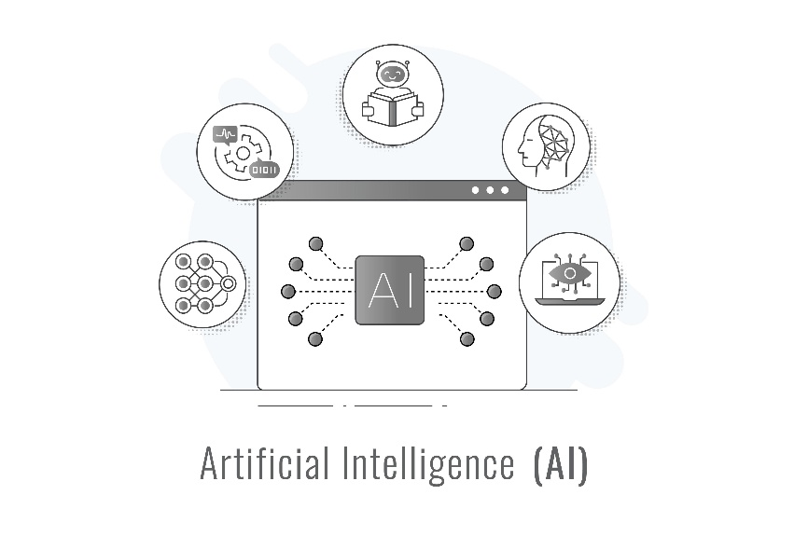
2 LLMs (Large Language Models)
- Description: A type of GenAI, specifically a deep learning model trained on massive amounts of text data to understand, summarize, generate, and predict human language. They are characterized by their large number of parameters (billions to trillions), which enables complex language tasks.
3 GANs (Generative Adversarial Networks)
- Description: A class of GenAI framework consisting of two neural networks—a Generator and a Discriminator—that compete with each other. The Generator creates new data (e.g., images), and the Discriminator tries to distinguish the real data from the generated fakes. This adversarial process helps the Generator produce increasingly realistic output.

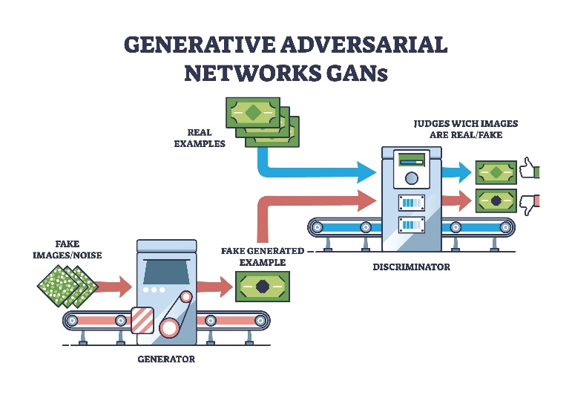

4 Vector
- Description: In the context of AI and data retrieval, a vector is a mathematical representation (a list of numbers) that captures the semantic meaning or features of a piece of data, such as a word, sentence, or image. Data points with similar meaning or characteristics have vectors that are numerically close to each other in a high-dimensional space.
5 VectorDB
- Description: A specialized database designed to store, manage, and query these numerical vectors efficiently. Unlike traditional databases that search by exact match (like a keyword or ID), a VectorDB performs similarity searches by quickly finding vectors that are closest to a query vector, enabling semantic search and recommendation systems.
6 RAG (Retrieval-Augmented Generation)
- Description: An architectural pattern that enhances the knowledge base of an LLM by integrating a retrieval step. When a user asks a question, RAG first retrieves relevant, specific, and up-to-date documents/data from an external knowledge source (often a VectorDB) and then provides that context to the LLM, allowing the model to generate a more accurate, grounded, and current answer.
7 LangChain
- Description: A framework designed to simplify the creation of applications powered by LLMs. It provides a structured way to chain together different components, such as LLMs, data sources (like VectorDBs), prompt templates, and various tools, making it easier to build complex, multi-step applications like RAG systems.
8 FAISS (Facebook AI for Semantic Search)
- Description: A software library developed by Facebook AI Research (Meta) for efficient similarity search and clustering of dense vectors. It provides algorithms that can quickly search through billions of vectors, often serving as the underlying index or component used within a VectorDB or for the retrieval step in a RAG system.

